CO4_AT2_Industry-based Problem
Name: Lavanya
Regno: 192521271
Course name: Design and analysis of algorithms
Course code: CSA0613
Question 23
Title
Smart Inventory Replenishment Optimization Using Dynamic Programming
1. Objective
To determine an optimal inventory replenishment schedule that minimizes the total ordering, holding, and shortage costs using Dynamic Programming.
2. Problem Description
A retail company needs to decide how much inventory to order during different periods.
The objective is to:
- Satisfy customer demand.
- Minimize inventory holding cost.
- Minimize shortage cost.
- Respect storage capacity.
- Determine an efficient replenishment schedule.
Algorithm
- Initialize the DP table.
- Start from the final period.
- Consider every possible inventory level.
- Try every feasible order quantity.
- Calculate holding, ordering, and shortage costs.
- Select the minimum-cost decision.
- Store the decision.
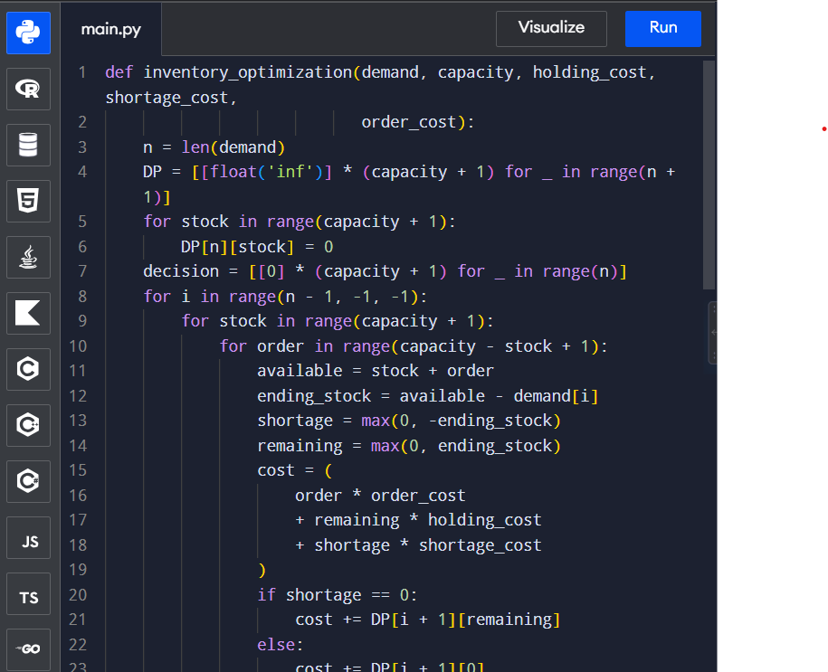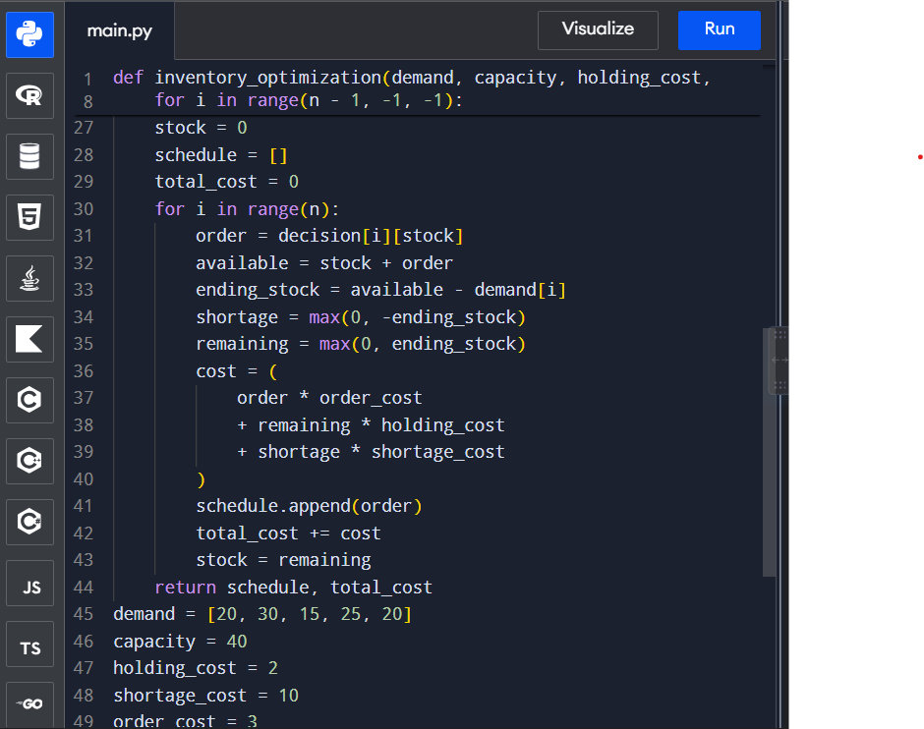
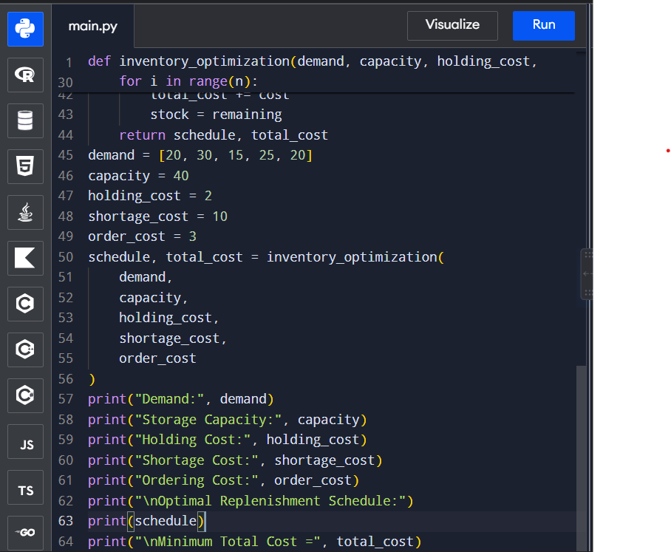

Input & Output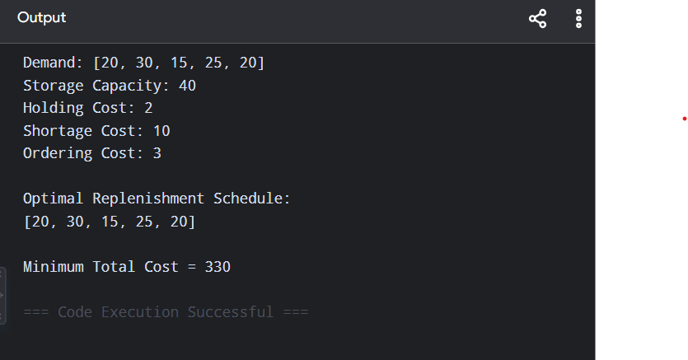

Analysis
Dynamic Programming avoids repeatedly solving the same inventory states.
For every period, it evaluates possible inventory levels and order quantities.
The algorithm finds a schedule that balances:
Ordering Cost + Holding Cost + Shortage Cost
↓
Minimum Total Cost

Efficiency
For:
- T = number of periods
- C = storage capacity
the basic implementation has approximately:
Time Complexity:
$$O\left(TC^{2}\right)$$
Space Complexity:
$$O\left(TC\right)$$
For larger supply-chain systems, optimization techniques, rolling DP tables, demand forecasting, and approximate methods can be used.

Documentation
Project: Smart Inventory Replenishment Optimization
Technique: Dynamic Programming
Purpose: To minimize the total inventory ordering, holding, and shortage costs.
The algorithm divides the inventory problem into smaller subproblems based on the time period and current inventory level. It evaluates different order quantities and selects the decision with minimum future cost.
The main recurrence is:
$$DP\left(i , s\right)=\min_{q}\left[CurrentCost+DP\left(i , +1s^{'}\right)\right]$$
where s' is the inventory remaining after satisfying demand.
The algorithm considers important constraints such as demand variability, storage capacity, shortage, and lead time.
For the sample data, the program produces an optimal replenishment schedule and minimum total cost.

Conclusion
The Smart Inventory Replenishment problem can be effectively formulated using Dynamic Programming. By considering inventory levels, demand, storage capacity, ordering costs, holding costs, and shortage costs, the algorithm determines an optimal replenishment schedule.
The approach is suitable for small and medium-sized inventory planning problems. For large-scale supply chains, it can be extended with forecasting, lead-time states, and optimization techniques.

